**AUTOMATION FRAMEWORK – GIT (SETUP)**

1. <https://dev.azure.com/qarttestautomation/_git/Quality_4634%20(20.4%20Testers)>
2. Click the “**Clone**” button:

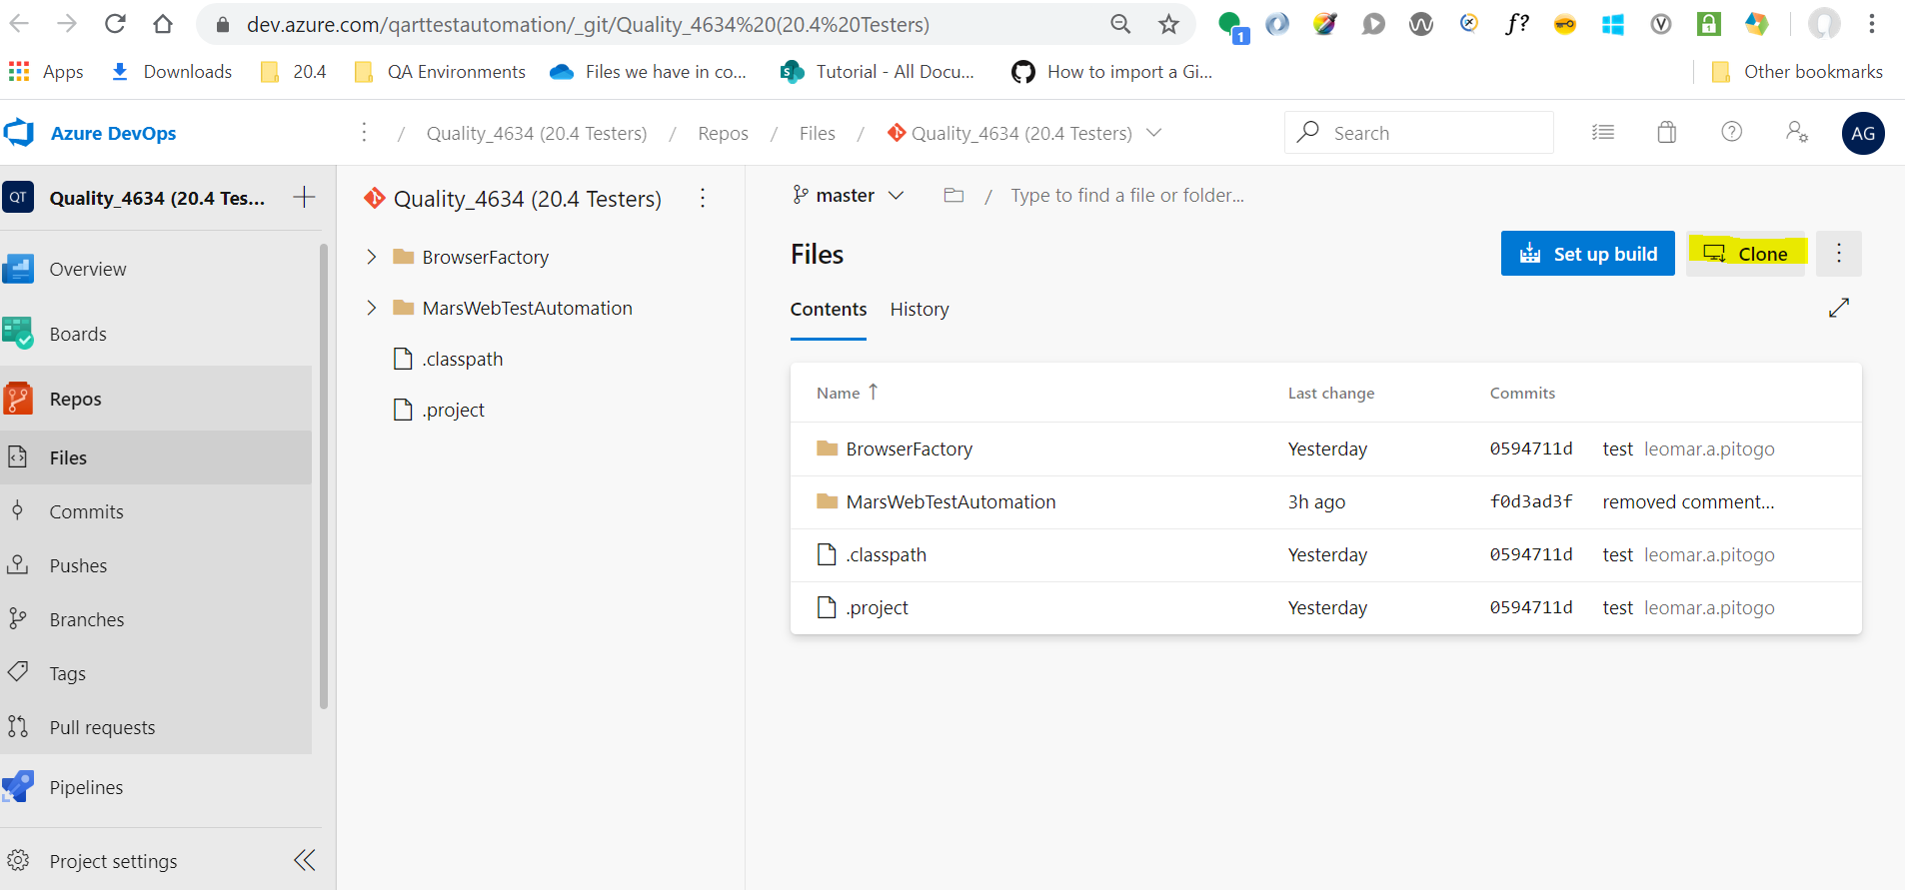

1. Click the “**Copy clone URL to clipboard**”:

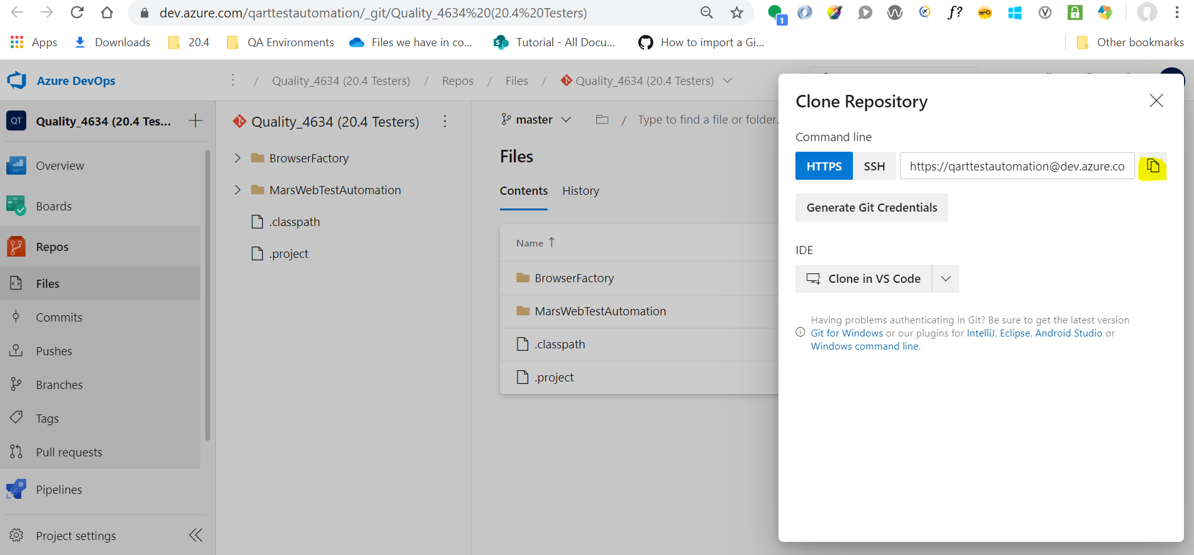

1. Click “**Generate Git Credentials**” button:

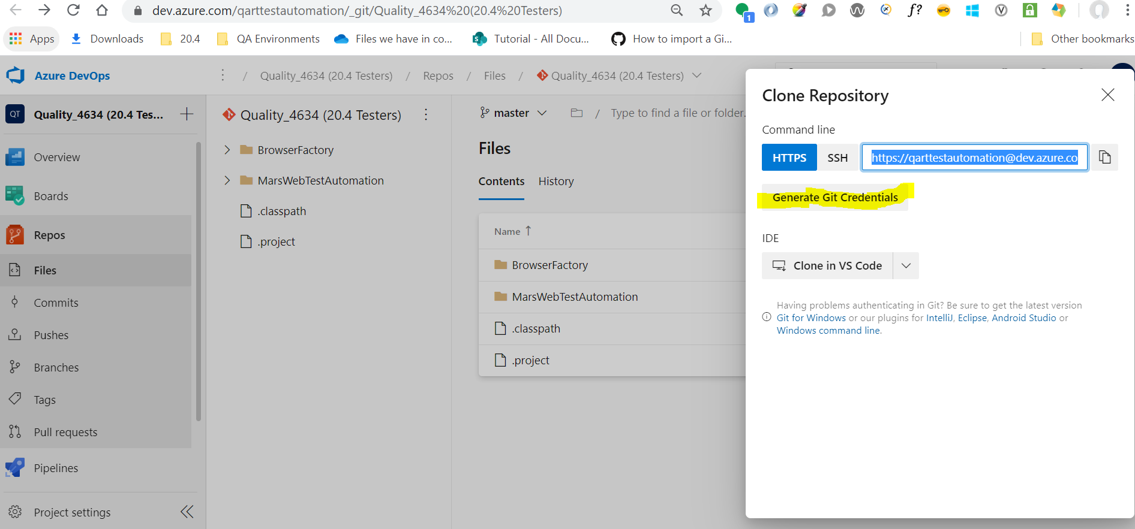

1. Copy the following data: **SSH**, **Username** and **Password**

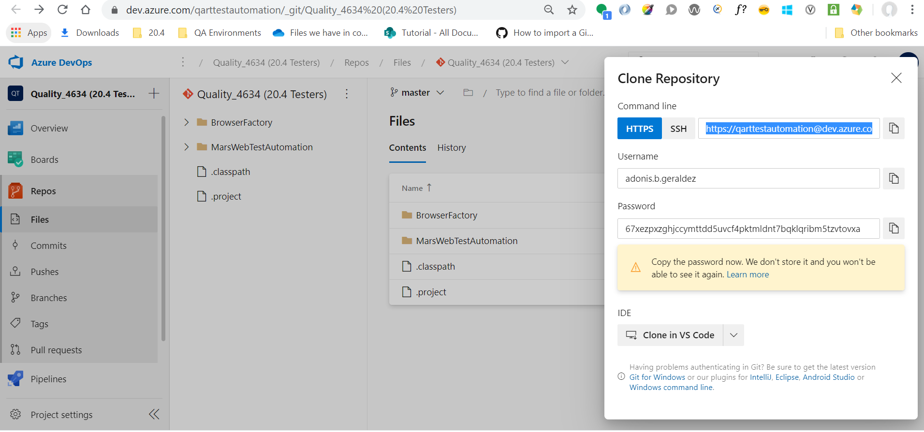

**IN ECLIPSE (Do the following:)**

1. Click “Window” tab

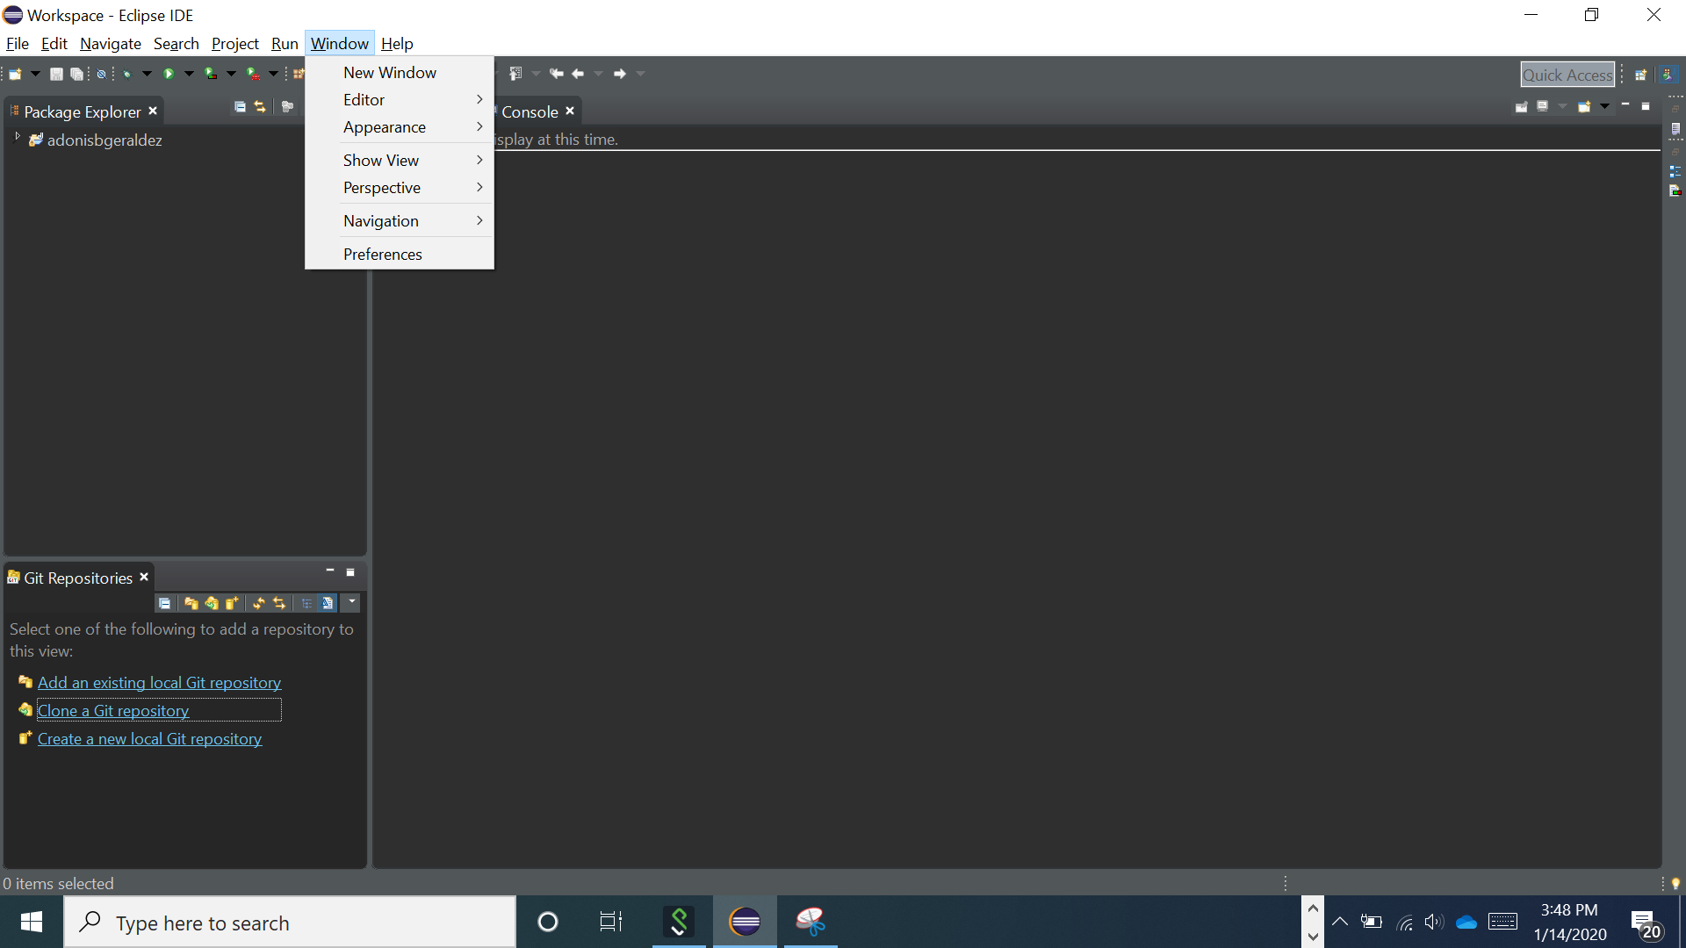

1. Click “**Show View**”

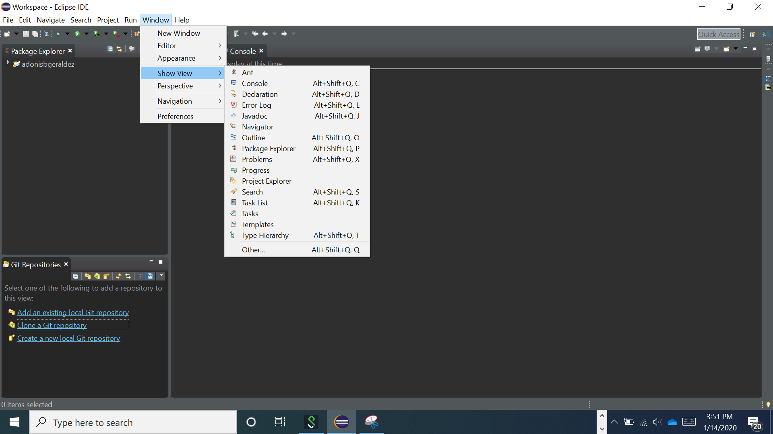

1. Click “**Other**”

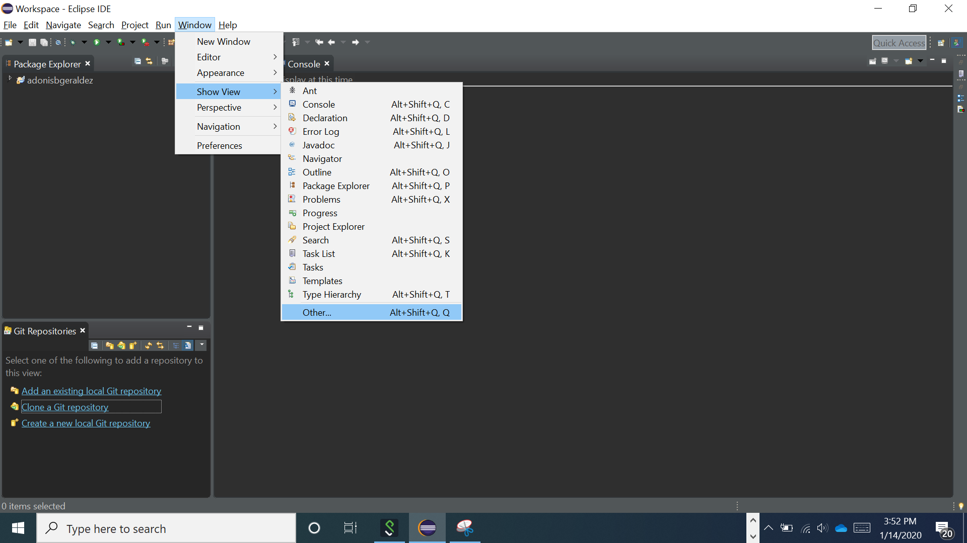

1. Click “**Git Repositories**” 🡪 “**Open**”

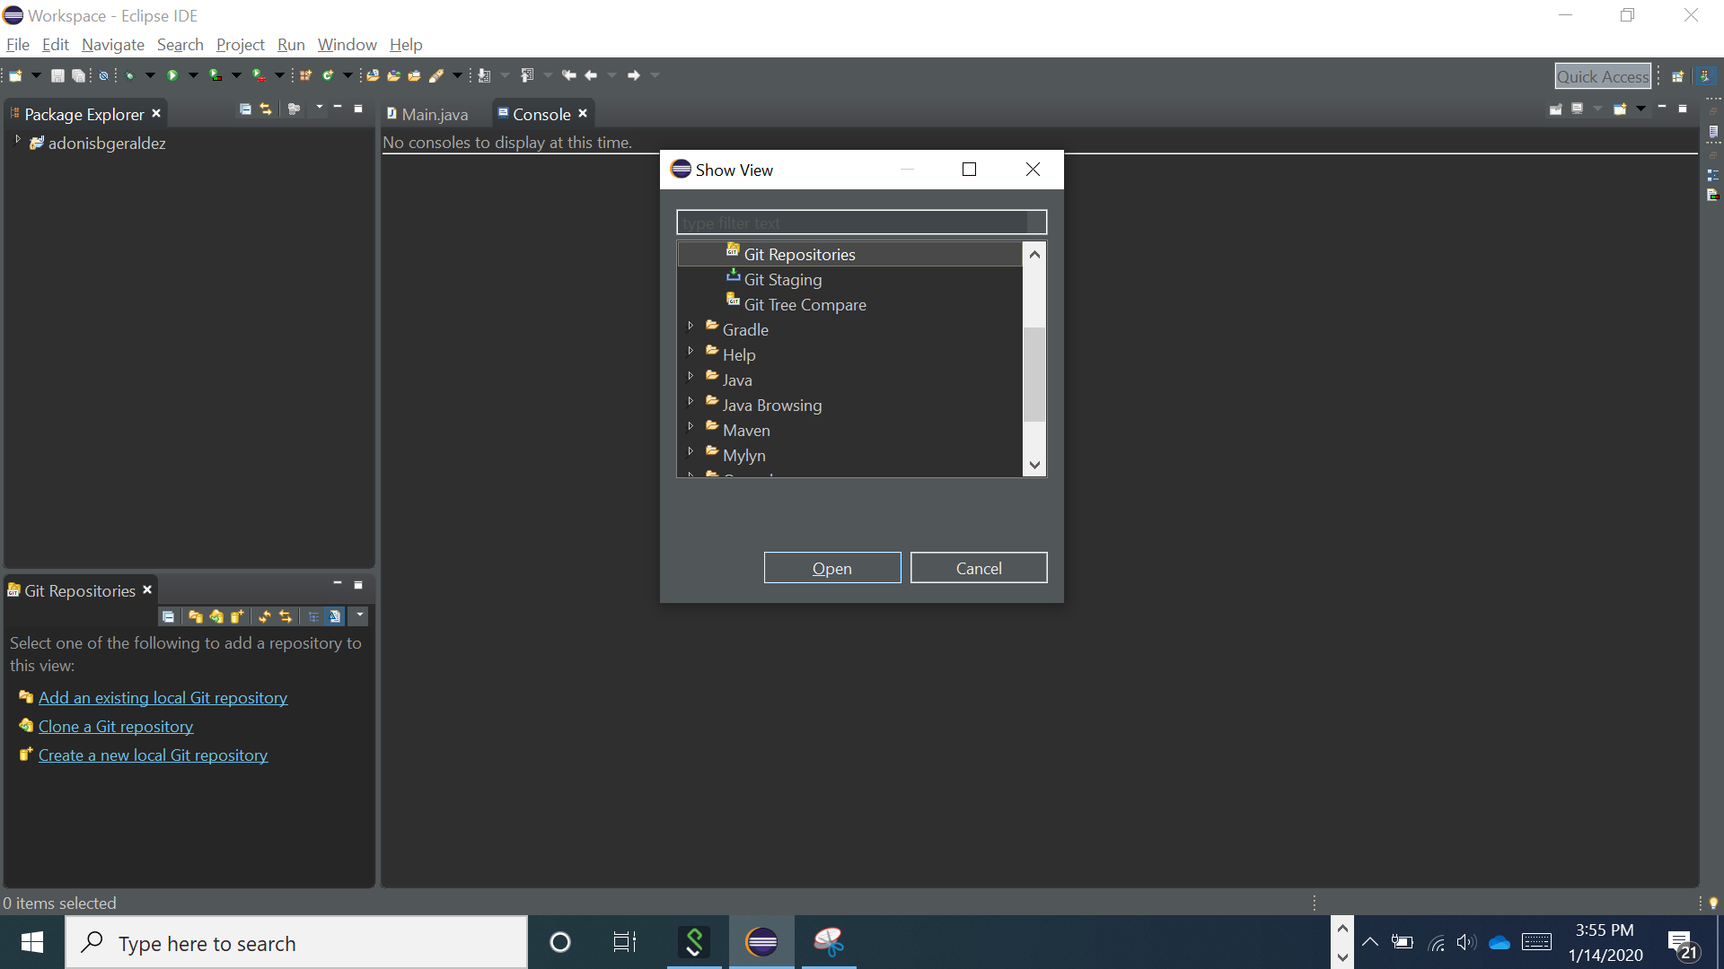

1. Click “**Clone a Git repositiory**”

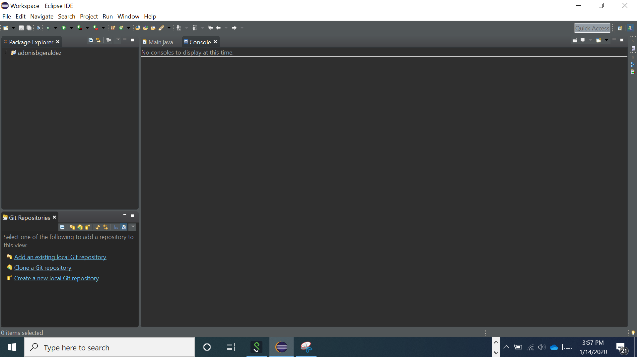

1. Paste the item you copied in **Step 3**

<https://qarttestautomation@dev.azure.com/qarttestautomation/Quality_4634%20%2820.4%20Testers%29/_git/Quality_4634%20%2820.4%20Testers%29>

1. Right-click the git repository 🡪 click “**Pull**” (the 1st one)

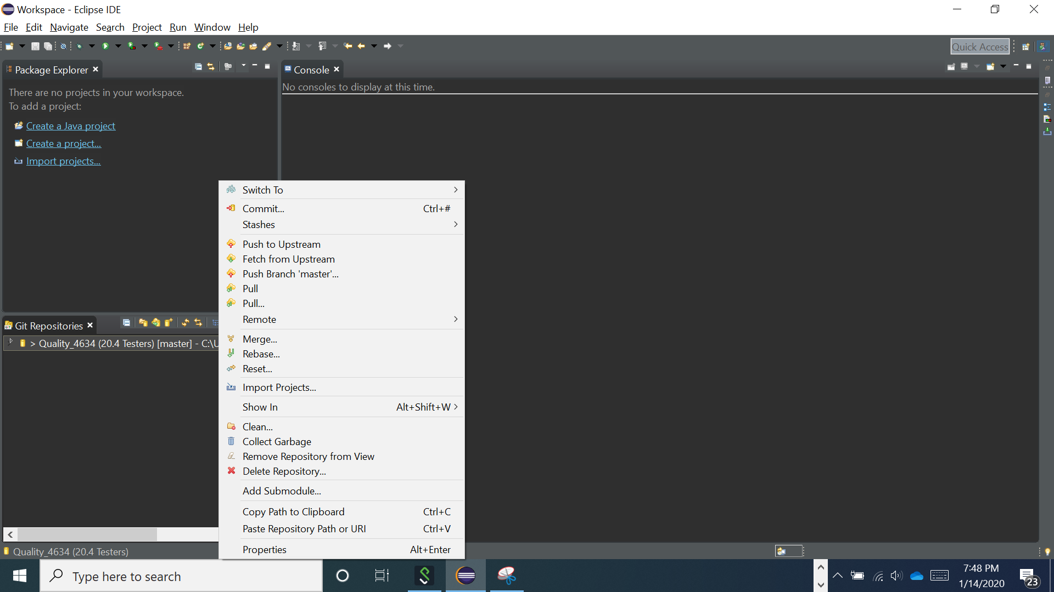

1. Click “**File**” 🡪 “**Open Projects from File System…**”

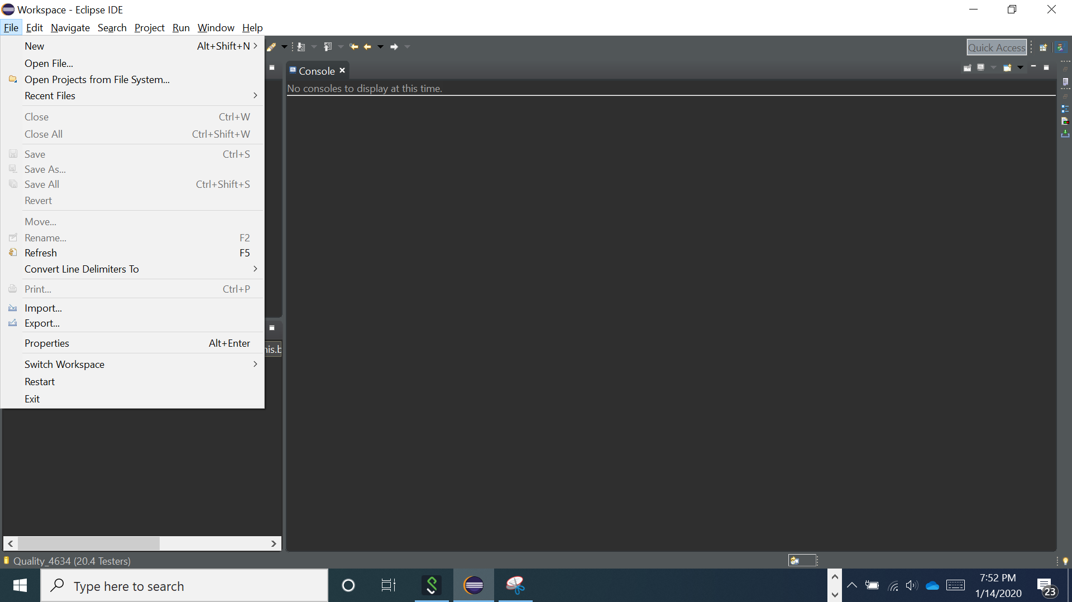

1. Click “**Directory**” then select/navigate to the specific folder

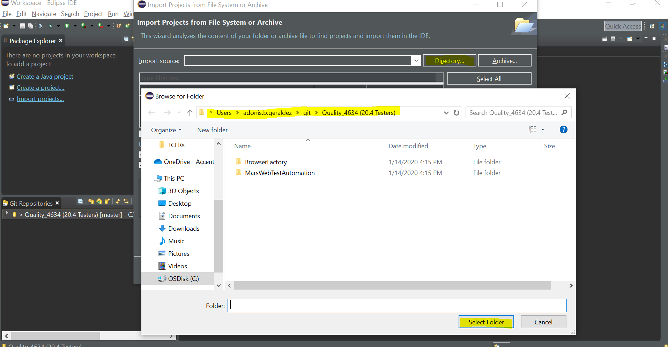

1. Import the specific folder and click “**Finish**”

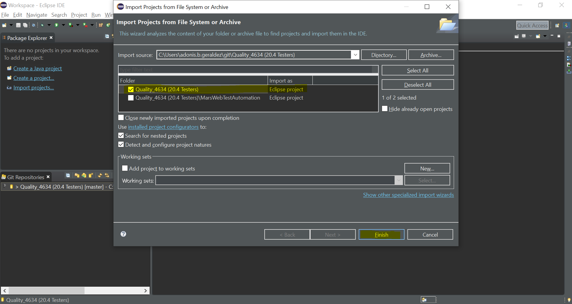

1. This will be now your local environment (ready for working the automation)

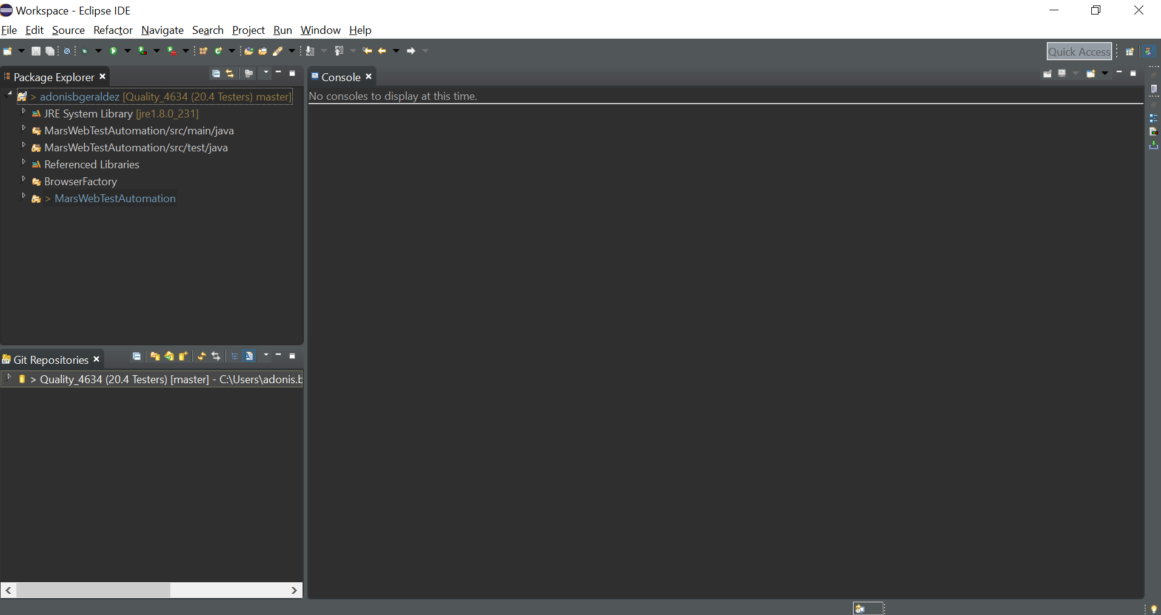

**RUNNING THE AUTOMATION**:

1. Right-click the “**Main.java**” 🡪 “**Run As**” 🡪 “**Java Application**”

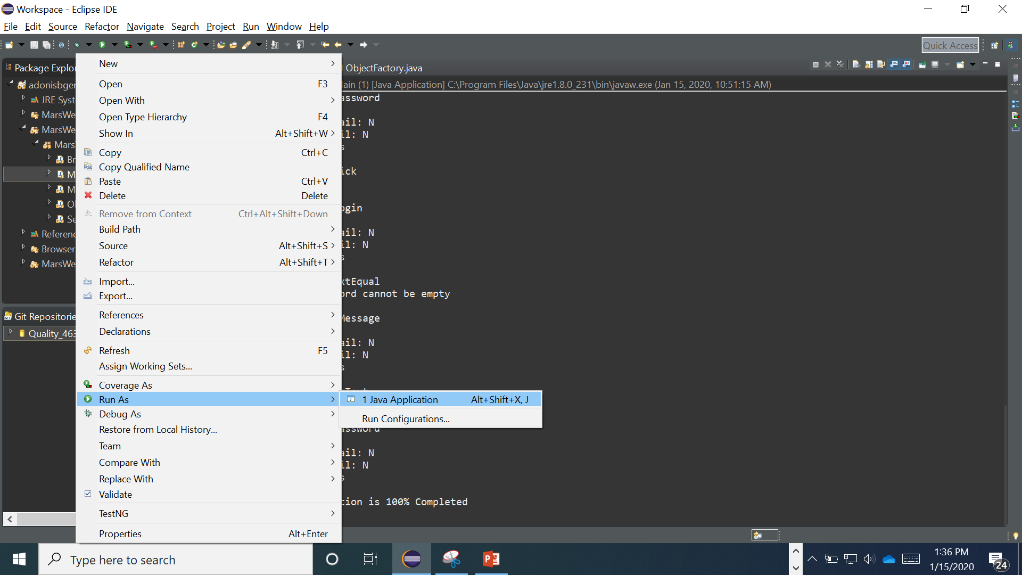

1. Locate the location of your TCER (excel file) 🡪 “**Open**” button

